Curriculum Vitae
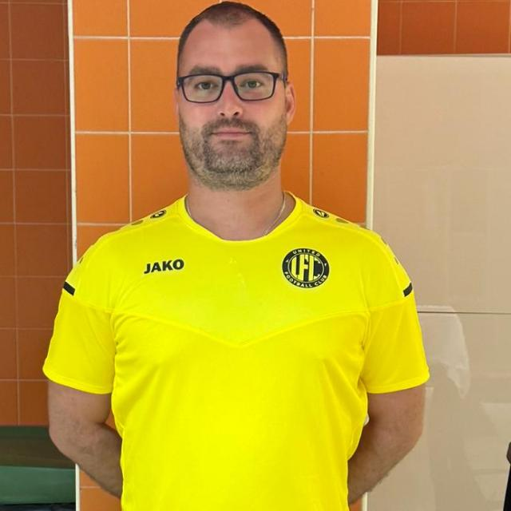

CONTACT INFORMATION

Full name  Name and Last name |  | Vladimir |  | Vuckovic
Address |  | Tuzlanska 17/1 |  | Belgrade, Serbia
Phone number |  | +381 60 4444 962 sms |  | +357 94433178 (whatc up, viber);  +971 502344624 (whatc up)
Email address |  | vlada041@gmail.com
PERSONAL
Gender |  | male
Age |  | 38
Nationality |  | Serbian
EDUCATION BACKGROUND
Degree program | Vocational therapist |  | Specialist vocational therapist |  | Sports therapist
University | School of Sport and Health, Belgrade |  | Faculty of Medicine, Belgrade |  | School of Sport and Health, Belgrade
Year of graduation | 2016 |  | 2012 |  | 2008
MENTHORSHIPS AND CERTIFICATIONS | MENTHORS |  |  | THE NAME OF THE INSTITUTION AND YEAR
 | Lecturer: Mr.Slobodan Brankovic |  |  | 2005-2008 SC ”Teleoptik” massages (soft, deep, lymph drainage, reflexology),  Serbia, Belgrade
 | Dragica Milutinović;  Physiotherapist educator, rehabilitation coordinator and mentor |  |  | February-August 2009 Clinical Center of Serbia, (training period), Department of Physical Medicine and Rehabilitation, Serbia, Belgrade
 | Chief: Prof.Dr Sci.Ljubica Konstantinović;  a specialist in physical medicine and rehabilitation |  |  | 2011-2012 Clinic for Rehabilitation "Dr. Miroslav Zotović ",  Serbia, Belgrade
 | Lecturer: Dr.Zlatko Fiser |  |  | August 2011 Certificate for completed course in Basic Life Support Measures and the Use of Automated External Defibrillator,  Serbia, StaraPazova
 | Lecturer: Dr.Dc.Aleksandar Sekulic |  |  | 2013-2015  Chiropractic, manipulation, joint mobilization, acupressure, assessment and treatment patient,  Serbia, Loznica
 | Lecturer:McsPt Steven L.H.DeConinck |  |  | June 2016 Certificate for the completed course CyraxMetod, Modul A, Serbia, Belgrade
 | Kinesio Group and textbook |  |  | March 2020  - Length, strength kinesio tape  - The Mulligan concept of manual therapy
 | Lecturer: Maja Rakic |  |  | June 2023  -Emmett technique
 | OMT TRAINING |  |  | July 2023  - Clinical compression flossing/voodo flossing techniques  - Trigger point therapy  - International diploma in myofascial cupping therapy for the treatment of myfascial pain
 | OMT TRAINING |  |  | February 2024  - Cervical/Thoracic/Lumbar spine seminar
 | PHYSIONEEDS ACADEMY |  |  | April/May 2024  - Certified tapedia expert  - Certified iastm expert
 | THE “GO-TO” THERAPIST MENTORSHIP CLINICAL SYSTEM |  |  | May 2024  Fast recovery
EMPLOYMENT HISTORY
MONTH and YEAR | EMPLOYMENT | MY ROLE
November 2019- June 2020 | Rehabilitation and training Center Stibo | electrotherapy and kinesitherapy, preparation and recovery sportsmen and citizen
January 2018-at January 2019 | Medical Center for Physical Medicine and Rehabilitation Milutin Ivkovic  Serbia, Belgrade | electrotherapy and kinesitherapy
September 2016-at present | Private practice  Serbia, Belgrade | Preparation and recovery of sportsmen and citizen
June 2011-December 2013 | Medical Center for Physical Medicine and Rehabilitation Family Doctor  Serbia, Belgrade | electrotherapy and kinesitherapy
April-August 2012 | Medical Center Ictus  Serbia, Belgrade | Rehabilitation citizen
August-October 2011 | Medical Center of Sports Medicine Mediks  Serbia, Belgrade | Preparation and recovery of sportsmen
March-August 2010 | Retirement homes Stent plus, Emerit and Encijan  Serbia, Belgrade | Rehabilitation elder people
February-August 2009 | Clinical Center of Serbia, Department of Physical Medicine and Rehabilitation  Serbia, Belgrade | Training period
Detailed Sport Specific Rehab Experience
August 2023-May 2024 | Football Club United  Dubai  Main Physiotherapist | Implementation of measures of electrotherapy, kinesitherapy, hidrotherapy and preventive measures, as well as taking care of injures before, during, and after completion of competitive games and training.
November 2022-May 2023 | Football Club Acritas Chlorakas  Cypar  Main Physiotherapist | Implementation of measures of electrotherapy, kinesitherapy, hidrotherapy and preventive measures, as well as taking care of injures before, during, and after completion of competitive games and training.
March 2023 | Football Club Auda  Latvia  Official Physiotherapist on preparations | preparation and recovery of footballers
April-September 2019  August 2020-September 2022 | Football Club Grindavik  Iceland  Main Physiotherapist | Implementation of measures of electrotherapy, kinesitherapy, hidrotherapy and preventive measures, as well as taking care of injures before, during, and after completion of competitive games and training.
September 2018 | Handball Club Al Kuwait SC and Burgan SC  Serbia, Ruma, Belgrade  Official Physiotherapist on preparations | Implementation of measures of physical therapy and preventive measures, as well as taking care of injures before, during, and after completion of competitive games and training.
June 2017 | European Championship in canoe Sprint Juniors and U23  Serbia, Belgrade  Physiotherapist at the tournament | Regenex Treatment is a combination of advanced technology and research and is used to quickly recover athletes from the central, peripheral, and chronic fatigue syndrome after training and competition, acute pain prevention, treatment of sports injuries, acute and chronic pain.
August 2015-April 2016 | Volleyball Club Telekom Baku  Azerbaijan, Baku  Official Physiotherapist on team | Implementation of measures of electrotherapy, kinesitherapy, hidrotherapy and preventive measures, as well as taking care of injures before, during, and after completion of competitive games and training.  European Champions League (1stround)  League Azerbaijan silver medal.
February 2010-March 2011  September 2014 -April2015 | Serbian Football Association  U19  Serbia, Belgrade  Official Physiotherapist on team | Implementation of measures of electrotherapy, kinesitherapy, hidrotherapy and preventive measures, as well as taking care of injures before, during, and after completion of competitive games and training.  Qualification European Championship 2015 (2nd round)
September 2012-2013 | Football clubs Šećeranac and Rušanj  Serbia, Belgrade  Official Physiotherapist on the match | preparation and recovery of footballers
February-April 2010 | Basketball clubs Viva-basket  Serbia, Belgrade  Official Physiotherapist on the match | preparation and recovery of basketball players
OTHER
December 2017 | Center for language Neven Telc, Germany language B1 level | Serbia, Belgrade
April 2017 | State exam for medical worker with University degrees | Serbia, Belgrade
June 2004 | Driving license (B category) | Serbia, Belgrade

